Industry vs Post-Graduate Studies: CS and IS Alumni Perceptions
Profs Andre Calitz, Jean Greyling and Margaret Cullen.
Department of Computing Sciences

Background
Students graduating from CS and IS departments face the question: Should I go and work in industry or should I complete post-graduate studies? The IT industry is currently experiencing a severe skill shortage and recruitment agencies and recruitment websites are continuously advertising posts for more than 10000 IT job vacancies in South Africa. IT graduates are encouraged to accept positions in industry in order to gain on-the-job experience. On the other hand, academics are encouraging graduates to continue their studies and complete post-graduate qualifications to make them more marketable, attain a more diverse IT skills set and earn higher salaries in the future. An increased number of post-graduate students is further also important for research in the CS/IS discipline.

This exploratory study focuses on the perceptions of Alumni (CS and IS graduates and post-graduates) and their opinion regarding the decision to work in industry or complete post-graduate studies. The advantages of deciding to go and work in industry were compared to completing post-graduate studies. Completing a Master’s degree in CS/IS versus studying a MBA was also investigated. According to literature, the soft-skills acquired during post-graduate studies include:
- Logical thinking;
- Work independently;
- Communication skills;
- Time management; and
- Developing an inquiring mind.
Research methodology
The Alumni Post-Graduate Perceptions survey was completed by Nelson Mandela University CS and IS Alumni (n = 111) working in the ICT industry. The five open-ended questions asked were:
- Why should/shouldn't a CS/IS graduate do an Honours in CS/IS?
- Are there reasons why an Honour’s student should stay on for 1-2 years and complete a CS/IS Master’s degree?
- Would you advise a post-graduate student to do a Masters in CS/IS or a MBA?
- When should a Master's degree student consider doing a PhD?
- Industry vs post-graduate studies. What advice would you give to a 3rd year student?

Results
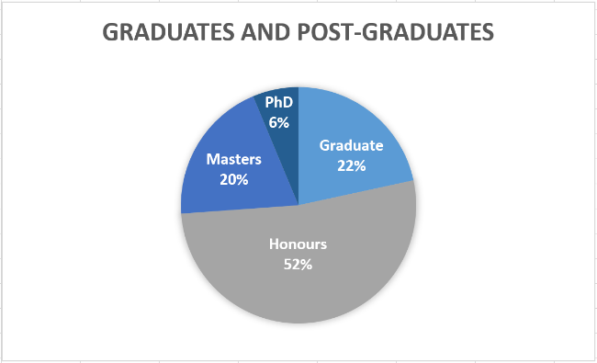
The distribution from the responses was Graduates (BCom and BSc; n=24; 22%), Honours (n=58, 52%), Masters (n=22, 20%) and PhD (n=7; 6%).

1. Why should/shouldn't a CS/IS graduate do an Honours in CS/IS?

The respondents (n=111) indicated that completing an Honour’s degree provides better job opportunities, provides in-depth knowledge of specific subject areas, distinguishes you in the market place and is important for overseas job opportunities. The negative comments relating to this question mainly focuses on finance and highlighted the importance of gaining relevant industry experience.

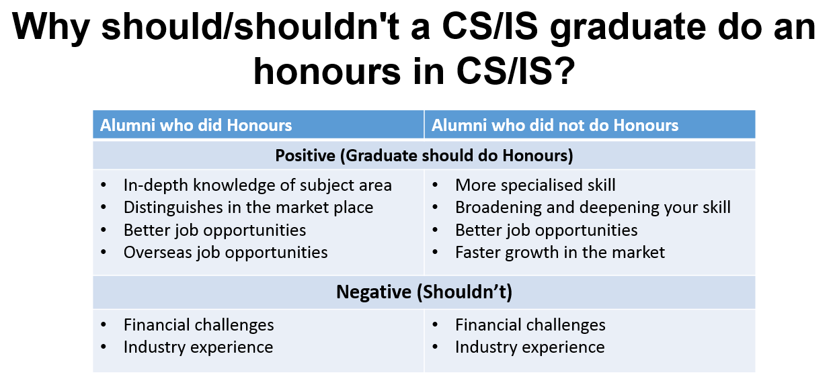
2. Are there reasons why an Honour’s student should stay on 1-2 years and complete a CS/IS Master’s degree?

The overall response to this question (n=111) was that the advanced degree provides better job opportunities, allows a student to specialise in a specific field, results in higher salaries, that it is important for overseas job opportunities and that it prepares a student for managerial positions. On the negative side, regarding the completion of a Master’s degree, the respondents indicated that you could become over qualified, that you should rather gain industry experience (15%) and that you should study part-time.

3. Completing a CS/IS Master’s degree versus a MBA
The majority indicated not to do either (36%; n=40), 18% (n=20) indicated a Master’s degree, 16% (n=18) indicated MBA and 28% (n=31) stated that it depended on where you were in your career and whether you wanted to move into management (study a MBA) or stay technology focused (do a Master’s degree). The graduate students (n=24) indicated it depended on the situation (42%, n=10), four (17%) recommended a MBA, one (4%) a Master’s degree and eight (33%) indicated not to do either. The Honour’s students (n=58, 52%) indicated it depended on the situation (n=12, 21%), nine (15%) recommended a MBA, thirteen (22%) recommended a Master’s degree and twenty-two (40%) indicated not to do either.
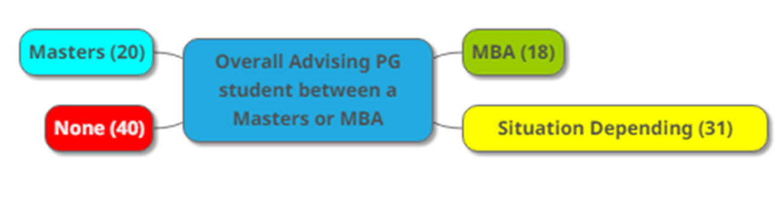
4. When should a Master's degree student consider doing a PhD?
The overall opinion of the Alumni respondents indicated that completing a PhD made you an expert in a specific field of study. The group indicated that you must do a PhD if you wanted to pursue an academic career (31%) or pursue research (12%).
5. Industry vs post-graduate studies. What advice would you give to a 3rd year student?
The overall group (n=109) indicated that post-graduate studies separate individuals in the job market (16%), it creates better job opportunities (20%) and most importantly, improves career opportunities (53%). Going into industry provides valuable industry experience (8%); it is better for your career (9%) and is a better platform to gain practical experience and knowledge (12%). The advice provided by M&D Alumni focused on skills demanded by industry and improved career opportunities by completing post-graduate studies first. They highlighted the fact that studying part-time and working is very difficult.
Conclusions
Post-graduates are students integral to research in academia. Post-graduate studies fosters career improvement, higher salaries and international employment possibilities. Based on the results, 3rd year students are generally advised to complete at least a 4-year degree or Honour’s degree. The decision to continue with a CS/IS Masters or a MBA depends on the individuals circumstances and career advancement prospects. Completing a Master’s degree or MBA is important specifically when Alumni wants to move into managerial positions, specifically after reaching the age of 40. Completing a PhD depends on the individual’s career plan to either stay in a technical environment, academia or to move into managerial positions. This research could assist academic CS/IS departments in providing relevant advice to students completing their 3rd year studies from a perspective of a graduate working in industry.
Full copy of the research paper is available by emailing andre.calitz@Mandela.ac.za
---------------------------------------------------------------------------------------------------

